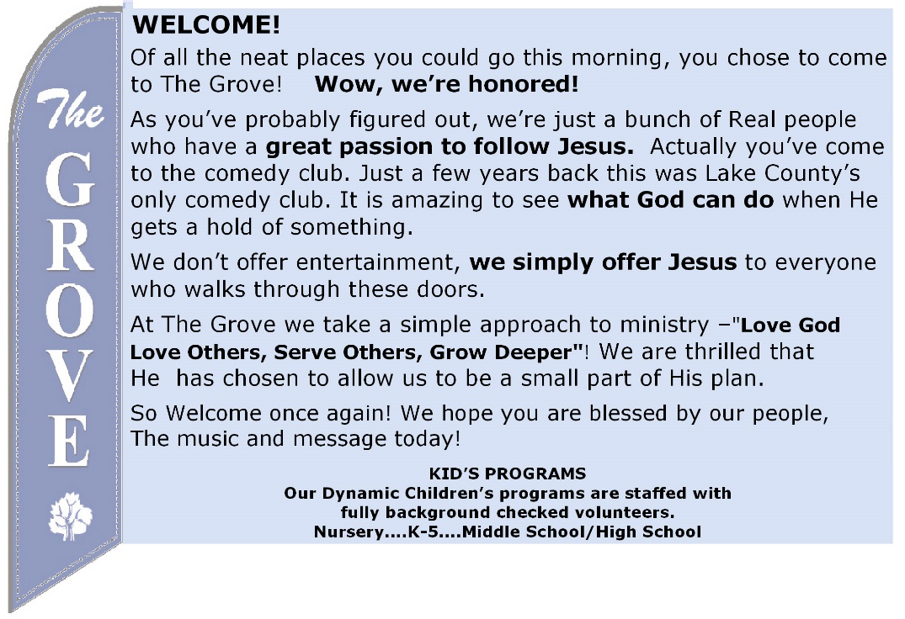
COFFEE IS BACK!
We are excited to be providing coffee and water to everyone who attends! Come a little early and share together – but remember we are keeping a safe distance from one another and wearing our masks.

TODAY!
Immediately following worship, we will have a short workshop to assist you in writing out your testimony in order to pursue membership at The Grove. Whether you’ve attended Grove 101 or not, all are invited.

Prayer time @ The Grove - Wednesdays - 6:30am!
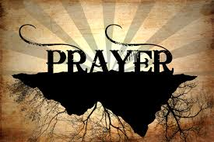
” Do not be anxious about anything, but in every situation, by prayer and petition, with thanksgiving, present your requests to God.” Phil 4:6

Do you like to make a joyful noise to the Lord? Do you have a musical talent but haven’t used it in a while? You are welcome to join our Worship Team no matter what your experience! We are not looking for standout musicians and soloists, just people who love music and would enjoy being part of a larger group on Sunday mornings. Speak with Pastor Jeff today to learn more!

MINISTRY OPPORTUNITY
The Grove is soon to reopen our Kids @ The Grove program! We are committed to raising up young disciples to a lifetime of service to God. If you are interested
in becoming part of our Kids @ The Grove ministry, contact Pastor Jeff.

MESSAGE NOTES: FOUNDATION PROBLEMS?

²⁴ “Therefore everyone who hears these words of mine and puts them into practice is like a wise man who built his house on the rock. ²⁵ The rain came down, the streams rose, and the winds blew and beat against that house; yet it did not fall, because it had its foundation on the rock. ²⁶ But everyone who hears these words of mine and does not put them into practice is like a foolish man who built his house on sand. ²⁷ The rain came down, the streams rose, and the winds blew and beat against that house, and it fell with a great crash.” Matthew 7:24-27.
- _________ HIS WORDS (vs 23)

- ________ HIS WORDS (vs.24)

- _____________ THE STORM (vs. 25)

With the help of the Holy Spirit my Next Step for today is:
For the first time I am accepting Jesus as my forgiver and leader.
I want to continue to build a strong foundation, sign me up for Grove 201 that will meet August 26th and September 2nd, 6:30-8:00pm at The Grove. (weather permitting)
I would like information on water baptism.

The Grove
1697 Mentor Ave. Painesville . OH . 44077
www.grovechurch.cc
Church Phone: 440.363.1160
Pastor Jeff cell: 440.463.2821
jsivyer01@gmail.com

“FOUNDATION PROBLEMS”
August 16, 2020

