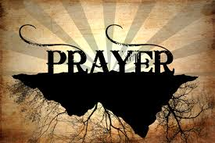
Prayer time via phone- Wednesday- 6:30am!
” Do not be anxious about anything, but in every situation, by prayer and petition, with thanksgiving, present your requests to God.” Phil 4:6

Saturday, September 26th, 9am-9pm!
Join Christians from across N/E Ohio @ The Grove as we join The Return via simulcast. Refreshments will be served at meal times. Watch for more details!

COMING SOON!
The Grove is committed to shifting our focus outwardly. A video series equipping everyone to be part of this outreach will be offered Sunday mornings at 9:00am. Start date TBA

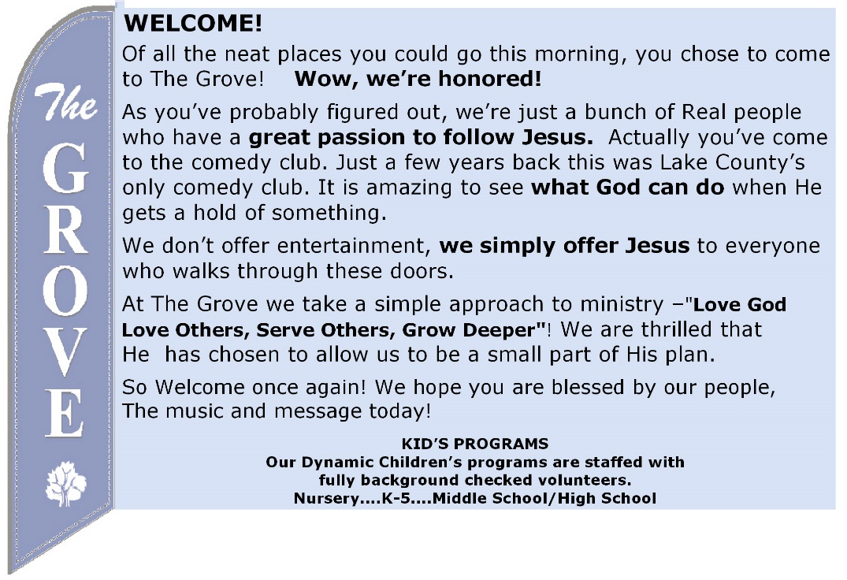
Do you like to make a joyful noise to the Lord? Do you have a musical talent but haven’t used it in a while? You are welcome to join our Worship Team no matter what your experience! We are not looking for standout musicians and soloists, just people who love music and the Lord and would enjoy being part of a larger group on Sunday mornings. Speak with Pastor Jeff today to learn more!

MINISTRY OPPORTUNITY
We are committed to raising up young disciples to a lifetime of service to God! Become part of our Kids @ The Grove ministry, contact Pastor Jeff today!

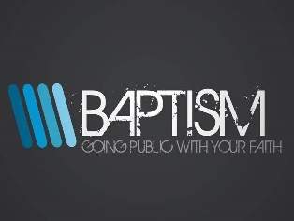
Why Be Baptized?
Three biblical reasons:

1- OBEDIENCE – being baptized is a first step of obedience for a Christian and should be done as soon as possible. Even Christ himself was baptized as our model in Matthew 3:13. Will you follow Christ in obedience and be baptized?

2- PUBLICLLY – Baptism is a public symbol of our private faith and is to be conducted in front of the entire church as a public expression. As a matter of fact, Jesus said very strongly in Matthew 10:32, "If anyone acknowledges me publicly here on earth, I will openly acknowledge that person before my Father in heaven.” Will you acknowledge Christ publicly next Sunday?

3- QUICKLY – While baptism does not bring salvation (only faith in Christ does), it should be done as quickly as possible after salvation. Every example in the New Testament is one of haste. There is always a reason to wait and always another excuse for delay, but let me encourage you to be like the Ethiopian follower in Acts 9 who saw a body of water right after his conversation and said "Look! There's some water! Why can't I be baptized?" (Acts 9:36) Why wait?

The Grove
1697 Mentor Ave. Painesville . OH . 44077
www.grovechurch.cc
Church Phone: 440.363.1160
Pastor Jeff cell: 440.463.2821
jsivyer01@gmail.com

“THE RETURN – PART 1
“Humility, Turning From Evil, Repentance”
September 6, 2020

The Way | Ben Smith | Daniel Bashta | Pat Barrett
Through every battle, Through every heartbreak
Through every circumstance, I believe that You are my fortress
Oh You are my portion, You are my hiding place
Oh I believe You are

The Way the Truth the Life
I believe You are
The Way the Truth the Life
I believe (You are)

Through every blessing, Through every promise
Through every breath I take, I believe that You are provider
You are protector, You are the One I love
I believe You are

It's a new horizon, And I'm set on You
And You meet me here today
With mercies that are new, All my fears and doubts
They can all come too, Because they can't stay long
(When I'm here with You) (When I believe You are)

CCLI Song # 7089024

O Come to the Altar | Chris Brown | Mack Brock | Steven Furtick

Are you hurting and broken within?
Overwhelmed by the weight of your sin?
Jesus is calling

Have you come to the end of yourself
Do you thirst for a drink from the well?
Jesus is calling

O come to the altar, The Father's arms are open wide
Forgiveness was bought with, The precious blood of Jesus Christ
Leave behind your regrets and mistakes
Come today there’s no reason to wait
Jesus is calling

Bring your sorrows and trade them for joy
From the ashes a new life is born
Jesus is calling

Oh what a savior, Isn't He wonderful?
Sing hallelujah, Christ is risen
Bow down before Him, For He is Lord of all
Sing Hallelujah, Christ is risen

Bear your cross as you wait for the crown
Tell the world of the treasure you found

CCLI Song # 7051511

Graves Into Gardens | Brandon Lake | Chris Brown | Steven Furtick | Tiffany Hammer

I searched the world but it couldn't fill me
Man's empty praise and treasures that fade
Are never enough
Then You came along and put me back together
And every desire is now satisfied here in Your love

Oh there's nothing better than You
There's nothing better than You
Lord there's nothing
Nothing is better than You

I'm not afraid to show You my weakness
My failures and flaws
Lord You've seen them all
And You still call me friend
'Cause the God of the mountain
Is the God of the valley
And there's not a place
Your mercy and grace won't find me again

You turn mourning to dancing
You give beauty for ashes
You turn shame into glory
You're the only one who can

You turn graves into gardens
You turn bones into armies
You turn seas into highways
You're the only one who can

CCLI Song # 7138219

THE RETURN – PART 1
“Humility, Turning From Evil, Repentance”

Jonah 1:2, 3:2-10

2 CHRONICLES 7:14.

Top 10 Things Pride Produces in Us
1. Pride fosters ____________ of God and His __________ Deuteronomy 8:11-14
2. Pride produces ____________ 2 Chronicles 32:24-25).
3. Pride leads to ____________ from God and self-sufficiency.
4. Pride causes us to make ______ __________ Prov 14:16, 18.
5. Pride prompts us to _____ in our ________ Psalm 31:18
6. Pride makes us to _______ we’re ________ than ________ Luke 18:9-11.
7. Pride causes us to _______ the ________ of others Proverbs 12:15; 13:1; 15:31, 32.
8. Pride encourages us to _____ our _____ to God’s ______ Proverbs 13:13-14; Jeremiah 13:8-10
9. Pride leads to a _____-______ life Proverbs 13:10.
10. Pride keeps us from ________ our own _____ Matt 7:1-5.
1 Peter 5:5-6
________ yourself with __________.

2 Peter 3:9-10, Proverbs 4:14, Psalm 51:5, Romans 7:18

How do we stay off the path of evil?
Do Not ________
_______
______ away and ______ on
“⁴ Don’t you realize how patient he is being with you? Or don’t you care? Can’t you see that he has been waiting all this time without punishing you, to give you time to turn from your sin? His kindness is meant to lead you to repentance.
⁵ But no, you won’t listen; and so you are saving up terrible punishment for yourselves because of your stubbornness in refusing to turn from your sin; for there is going to come a day of wrath when God will be the just Judge of all the world.“ Romans 2:4-5

With the Holy Spirit’s Help my Next Step today is:
Today I have identified what pride has produced in me: forgetfulness of God, ingratitude, independence, poor decisions, sin in my speech, thinking I’m better than others, reject the wisdom of others, close my ears to God’s Word, strife filled life, from seeing my own sin.
The one thing I can do, or stop doing, during our 40 day fast that will help me avoid evil is ____________.)
Today, I turn from ______________ so that I may be free

