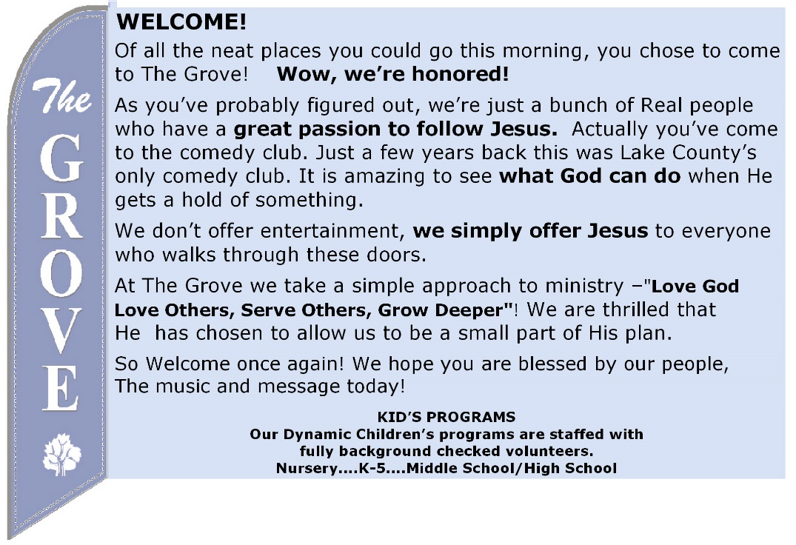
COFFEE IS BACK!
We are excited to be providing coffee and water to everyone who attends! Come a little early and share together – but remember we are keeping a safe distance from one another and wearing our masks.

NEXT SUNDAY!
Immediately following worship, we will have a short workshop to assist you in writing out your testimony in order to pursue membership at The Grove. Whether you’ve attended Grove 101 or not, all are invited.

Prayer time @ The Grove - Wednesdays - 6:30am!
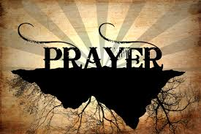
” Do not be anxious about anything, but in every situation, by prayer and petition, with thanksgiving, present your requests to God.” Phil 4:6

Do you like to make a joyful noise to the Lord? Do you have a musical talent but haven’t used it in a while? You are welcome to join our Worship Team no matter what your experience! We are not looking for standout musicians and soloists, just people who love music and would enjoy being part of a larger group on Sunday mornings. Speak with Pastor Jeff today to learn more!

MINISTRY OPPORTUNITY
The Grove is soon to reopen our Kids @ The Grove program! We are committed to raising up young disciples to a lifetime of service to God. If you are interested
in becoming part of our Kids @ The Grove ministry, contact Pastor Jeff.

AUGUST 9, 2020 SONGSHEET
Great Things | Jonas Myrin | Phil Wickham
Come let us worship our King
Come let us bow at His feet
He has done great things
See what our Savior has done
See how His love overcomes
He has done great things
He has done great things
O Hero of Heaven You conquered the grave
You free every captive and break every chain
O God You have done great things
We dance in Your freedom awake and alive
O Jesus our Savior Your name lifted high
O God You have done great things
You’ve been faithful through every storm
You’ll be faithful forevermore
You have done great things
And I know You will do it again
For Your promise is yes and amen
You will do great things
God You do great things
Hallelujah God above it all
Hallelujah God unshakable
Hallelujah You have done great things
(REPEAT)
You’ve done great things
You have done great things
O God You do great things CCLI Song # 7111321
Lord, I Need You | Christy Nockels | Kristian Stanfill | Matt Maher
Lord, I come, I confess
Bowing here I find my rest
Without You I fall apart
You're the One that guides my heart
Lord, I need You, oh, I need You
Every hour I need You
My one defense, my righteousness
Oh God, how I need You
Where sin runs deep Your grace is more
Where grace is found is where You are
And where You are, Lord, I am free
Holiness is Christ in me
Lord, I need You, oh, I need You
Every hour I need You
My one defense, my righteousness
Oh God, how I need You
Teach my song to rise to You
When temptation comes my way
And when I cannot stand I'll fall on You
Jesus, You're my hope and stay
Lord, I need You, oh, I need You
Every hour I need You
My one defense, my righteousness
Oh God, how I need You
You're my one defense, my righteousness
Oh God, how I need You
My one defense, my righteousness
Oh God, how I need You

CCLI Song # 5925687

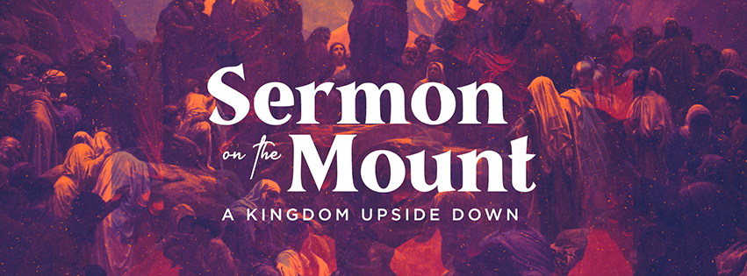
“FURTHER WARNINGS”
August 9, 2020

